**106118106 LAB2**

**Q1**

use mysampldb;

DROP TABLE books;

CREATE TABLE books (

BOOKNO INT(3),

TITLE VARCHAR(50),

PUBLICATION VARCHAR(50),

AUTHOR VARCHAR(100),

PRICE DECIMAL(6,2),

QUANTITY INT(3),

EDITION INT(2),

PRIMARY KEY (BOOKNO),

CHECK(QUANTITY<=100)

);

SELECT * FROM books;

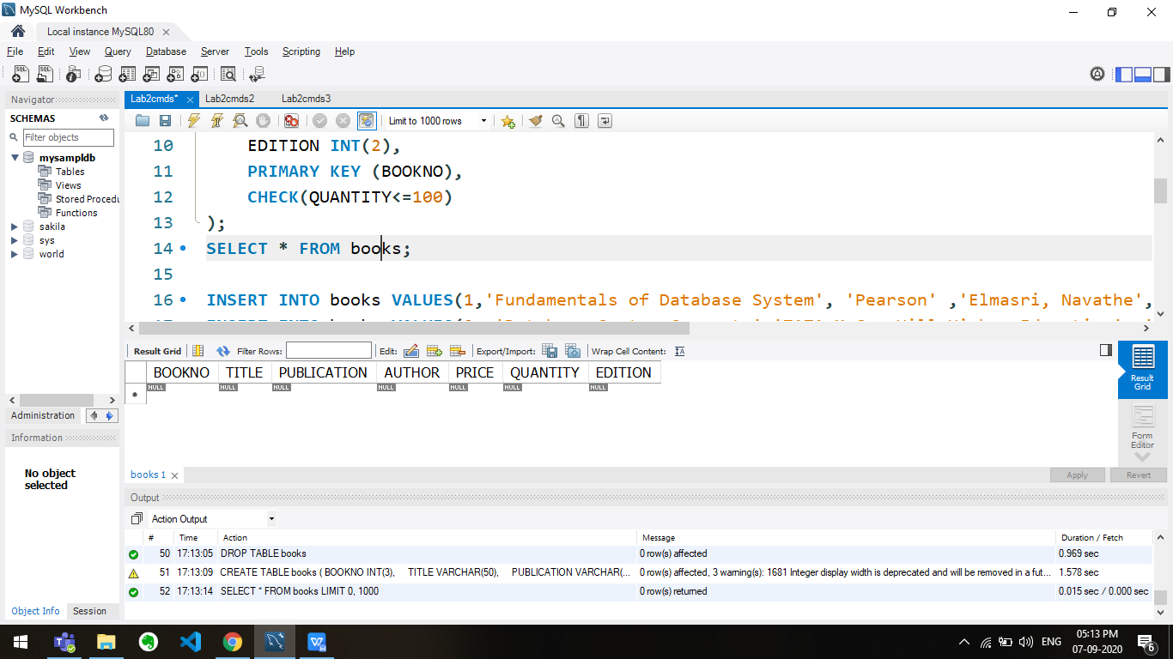

INSERT INTO books VALUES(1,'Fundamentals of Database System', 'Pearson' ,'Elmasri, Navathe', 800, 25, 7);

INSERT INTO books VALUES(2, 'Database System Concepts','TATA McGrawHill Higher Education', 'Silberschatz, Korth, Sudharshan', 750, 15, 7);

INSERT INTO books VALUES(3, 'Database Management System', 'TATA McGraw Hill', 'Raghurama Krishnan, Johannes Gehrke', 590, 10, 3);

INSERT INTO books VALUES(4, 'Datastructures and Algorithm', 'Pearson', 'H. Cormen', 1080, 5, 6);

INSERT INTO books VALUES(5, 'Operating system concepts', 'Wiley', 'Silberschatz, Galvin, Gagne', 640, 8, 6);

INSERT INTO books VALUES(6, 'Modern Operating System', 'Prentice Hall India', 'Tanenbaum', 890, 23, 2);

INSERT INTO books VALUES(7, 'Computer Networks', 'PHI', 'Kurose, Ross', 390, 102, 6);

SELECT * from books;

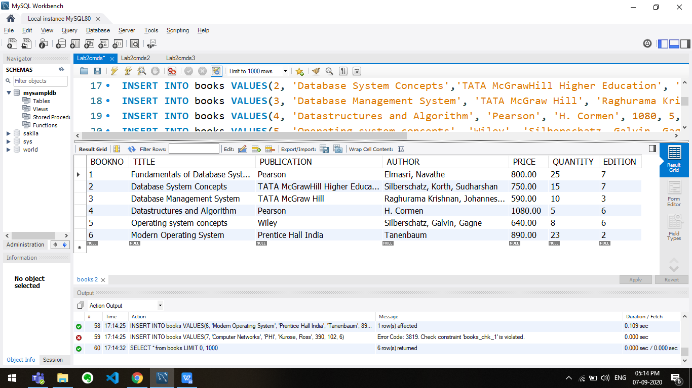

SELECT TITLE,AUTHOR FROM books;

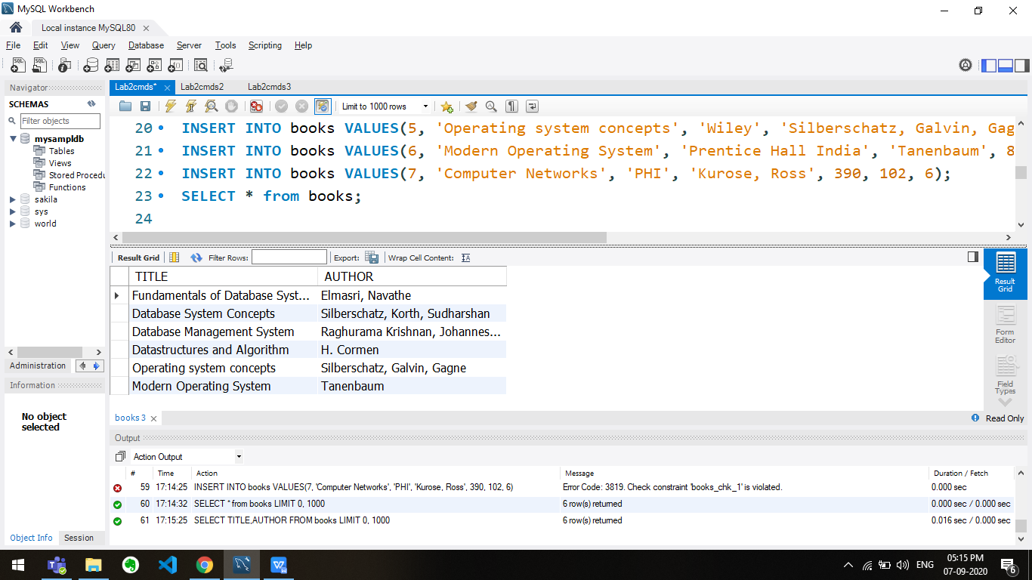

SELECT AUTHOR FROM books WHERE TITLE='Database System Concepts';

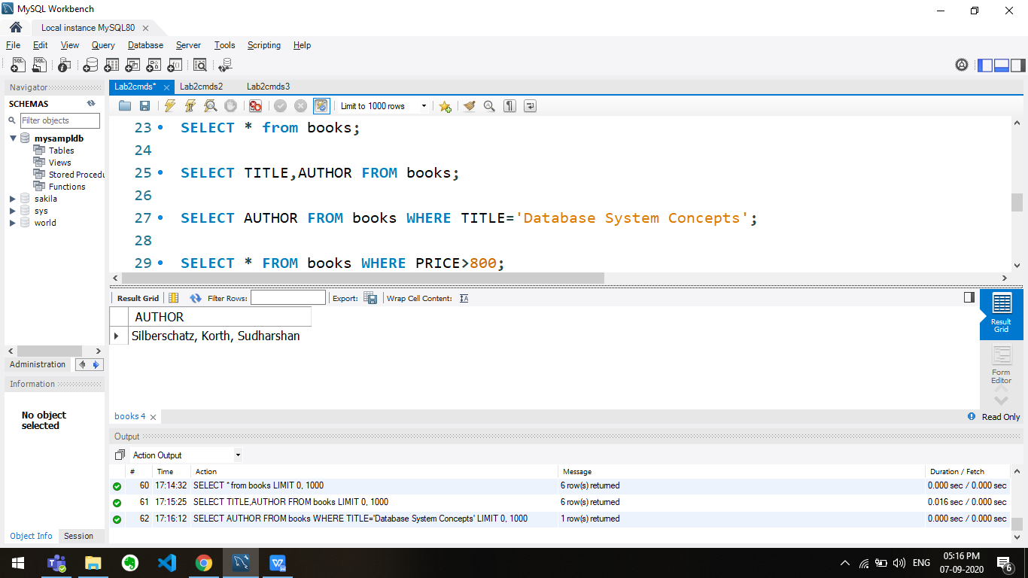

SELECT * FROM books WHERE PRICE>800;

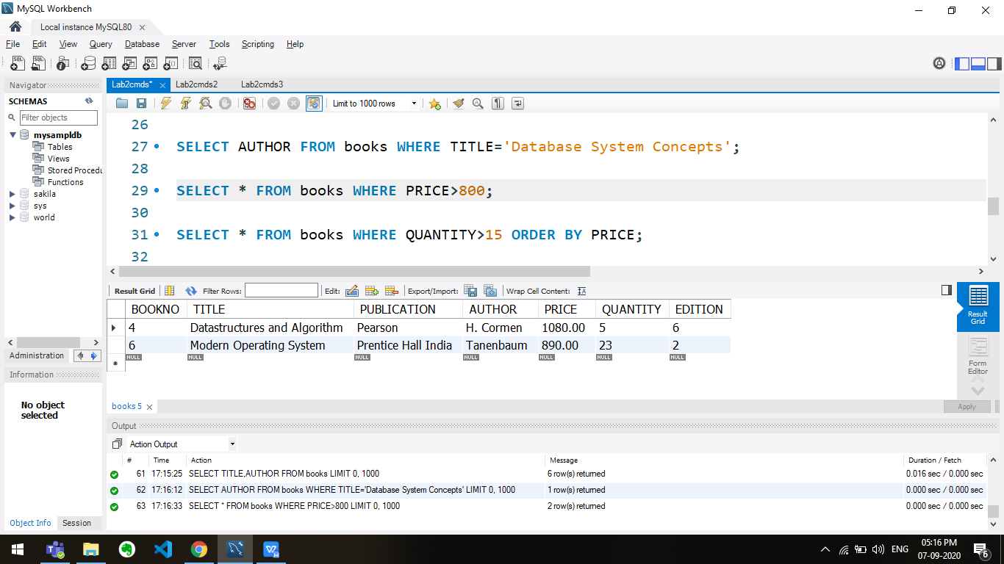

SELECT * FROM books WHERE QUANTITY>15 ORDER BY PRICE;

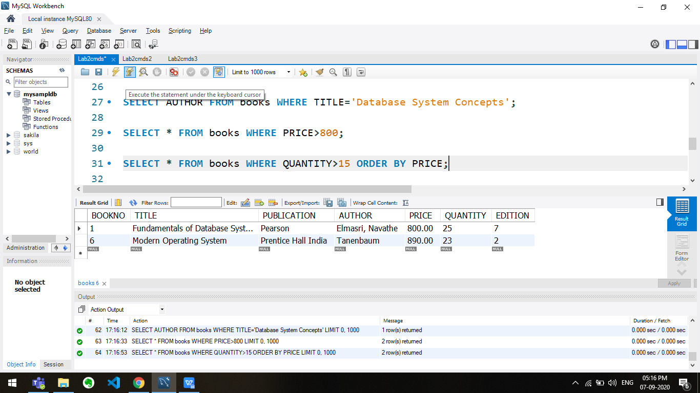

SELECT * FROM books WHERE PUBLICATION LIKE 'P___%';

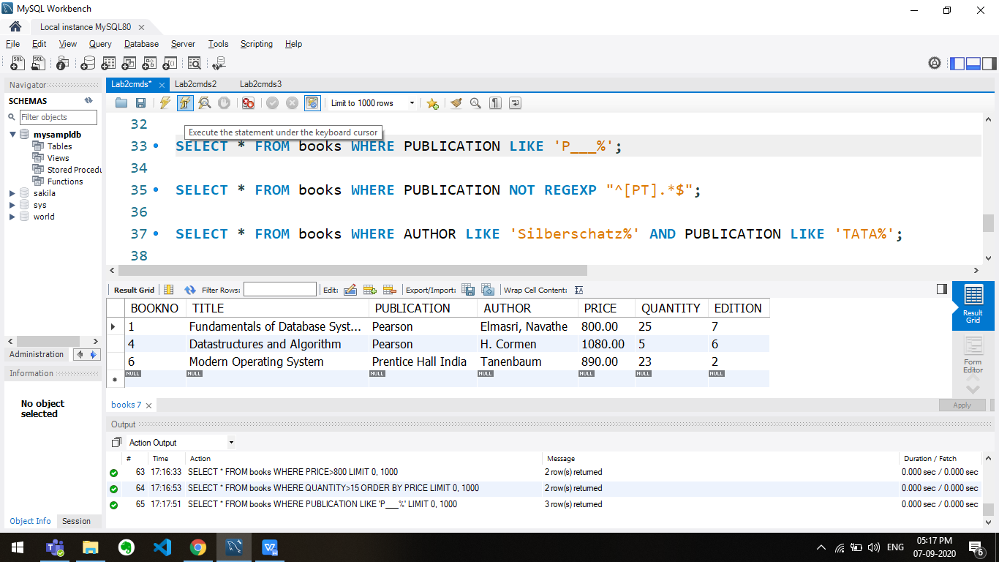

SELECT * FROM books WHERE PUBLICATION NOT REGEXP "^[PT].*$";

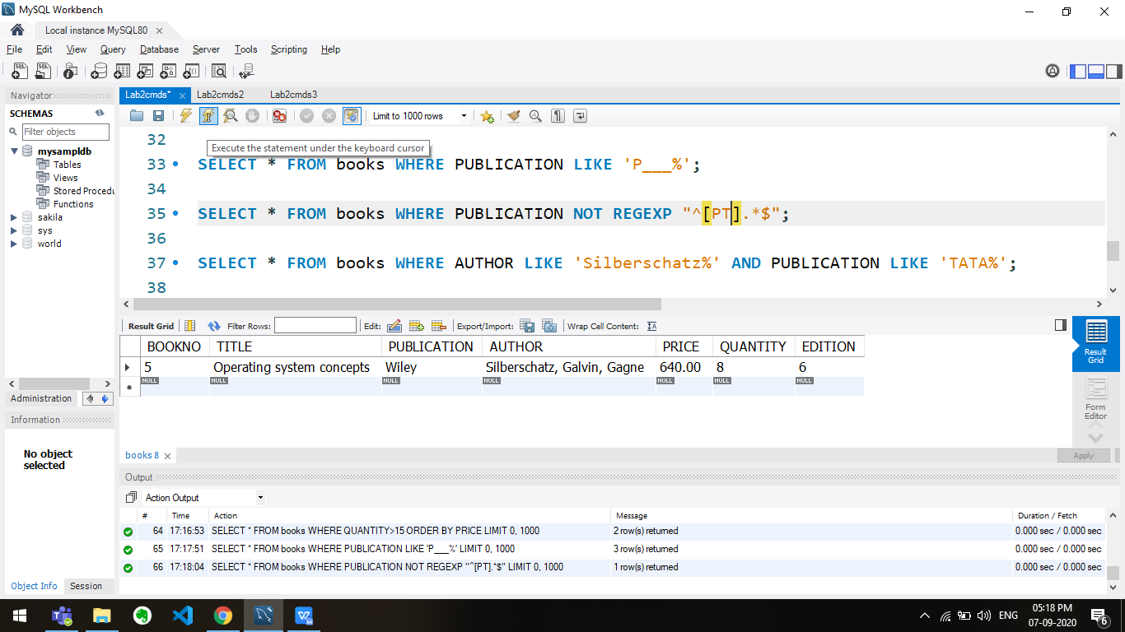

SELECT * FROM books WHERE AUTHOR LIKE 'Silberschatz%' AND PUBLICATION LIKE 'TATA%';

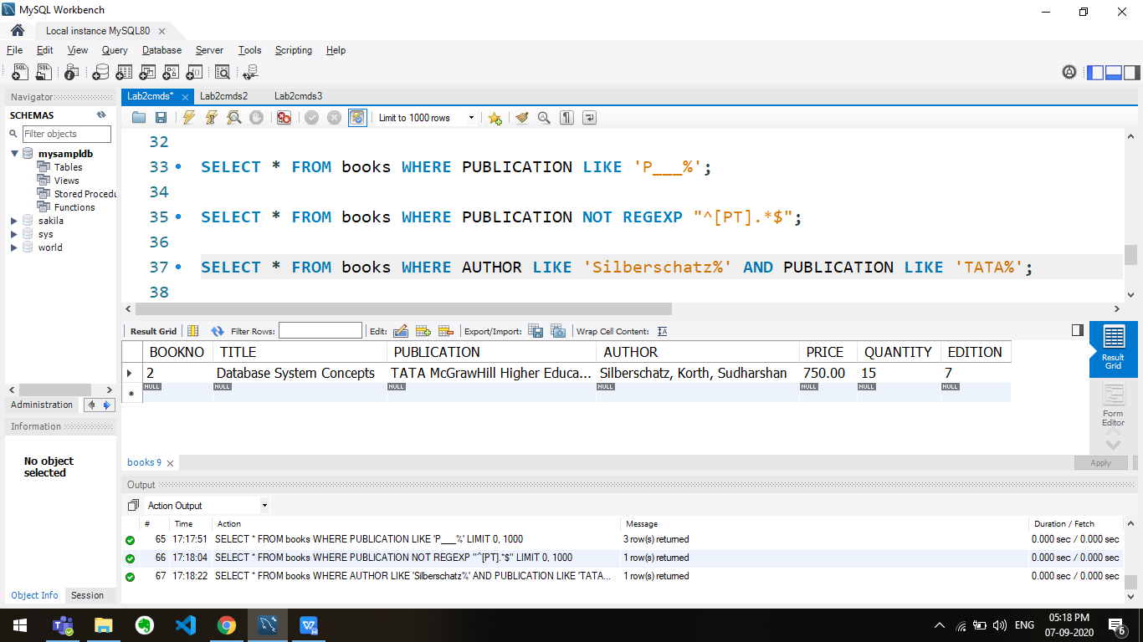

SELECT * FROM books WHERE TITLE LIKE '%CONCEPTS%';

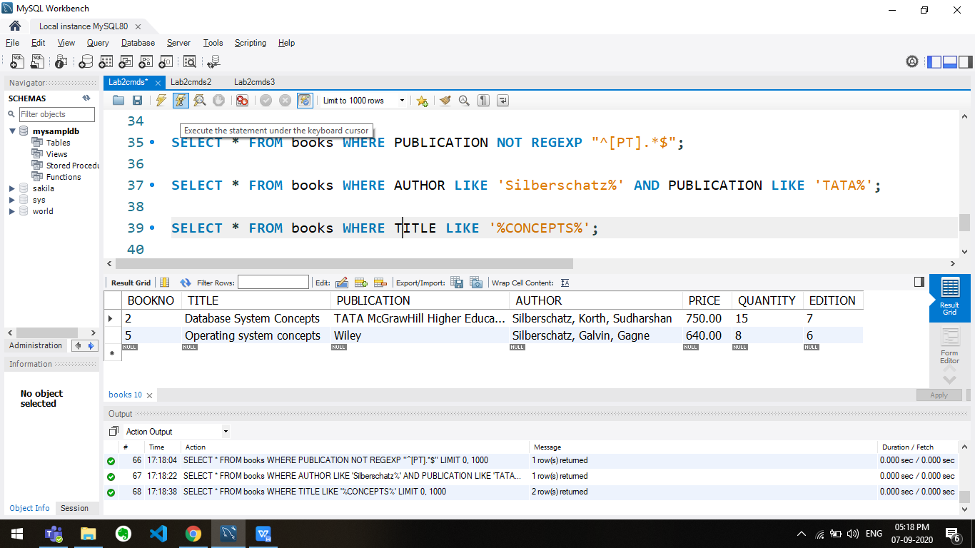

UPDATE books SET PRICE = (PRICE*1.1) WHERE PUBLICATION='Pearson';

SELECT * FROM books;

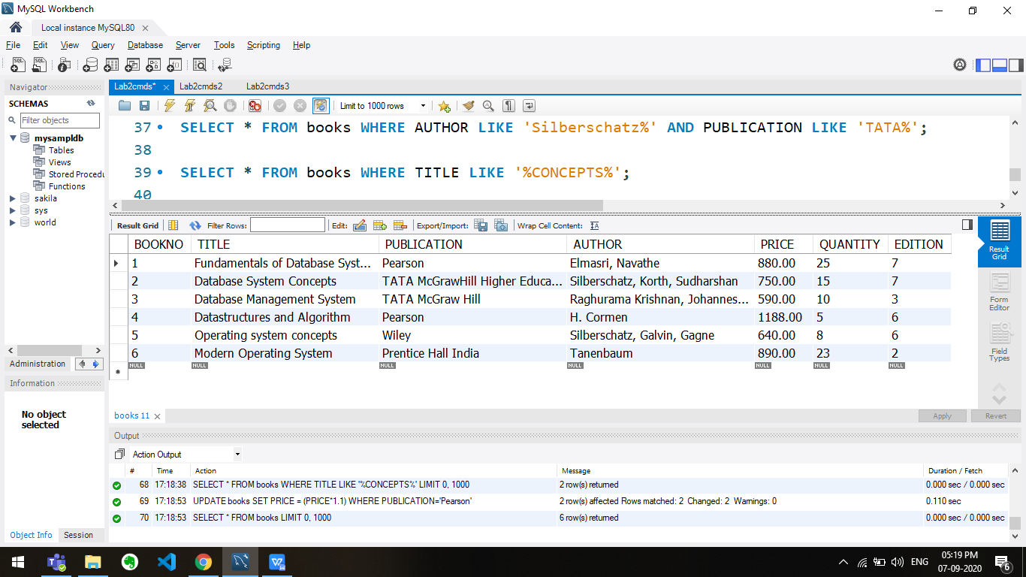

**Q2**

use mysampldb;

DROP TABLE ISSUE;

CREATE TABLE ISSUE

(BOOKNO INT(3),

STUDENTNO INT(3),

ISSUEDATE DATETIME,

RETURNDATE DATETIME,

PRIMARY KEY(BOOKNO)

);

SELECT * FROM ISSUE;

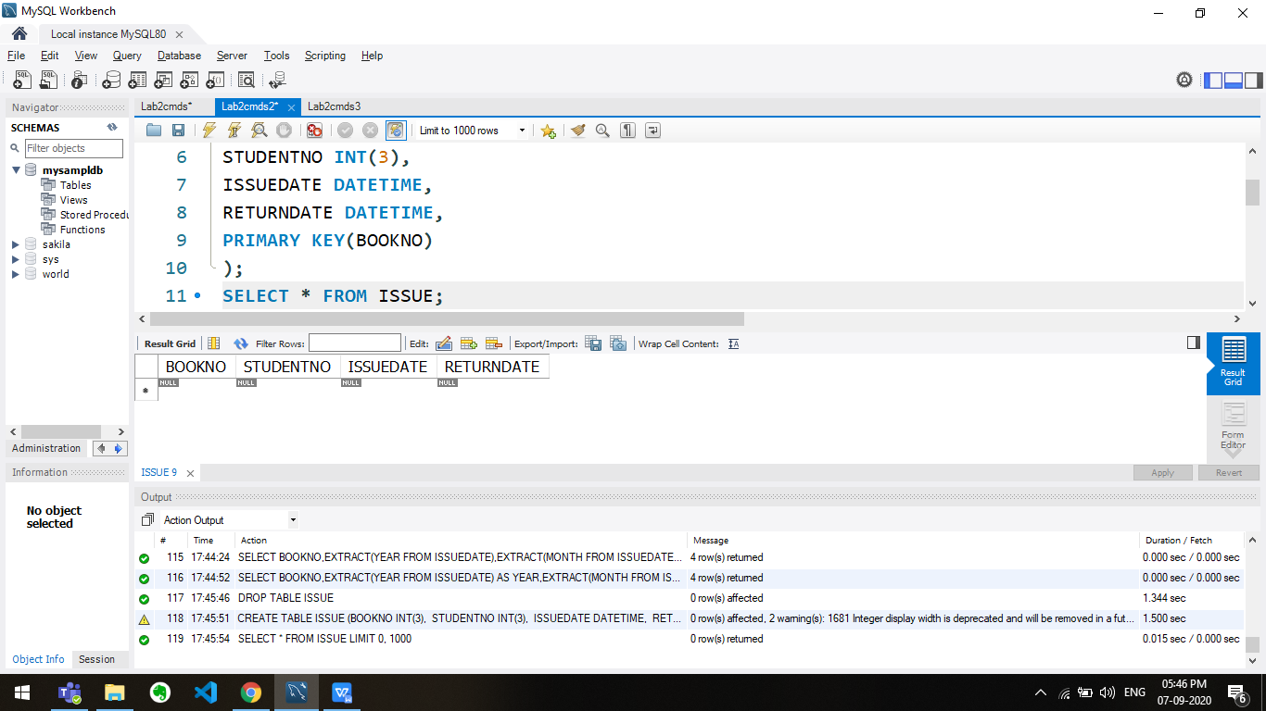

INSERT INTO ISSUE VALUES ('1','1','2020-09-01','2020-09-03');

INSERT INTO ISSUE VALUES ('2','2','2020-09-02','2020-09-04');

INSERT INTO ISSUE VALUES ('3','3','2020-09-03','2020-09-05');

SELECT * FROM ISSUE;

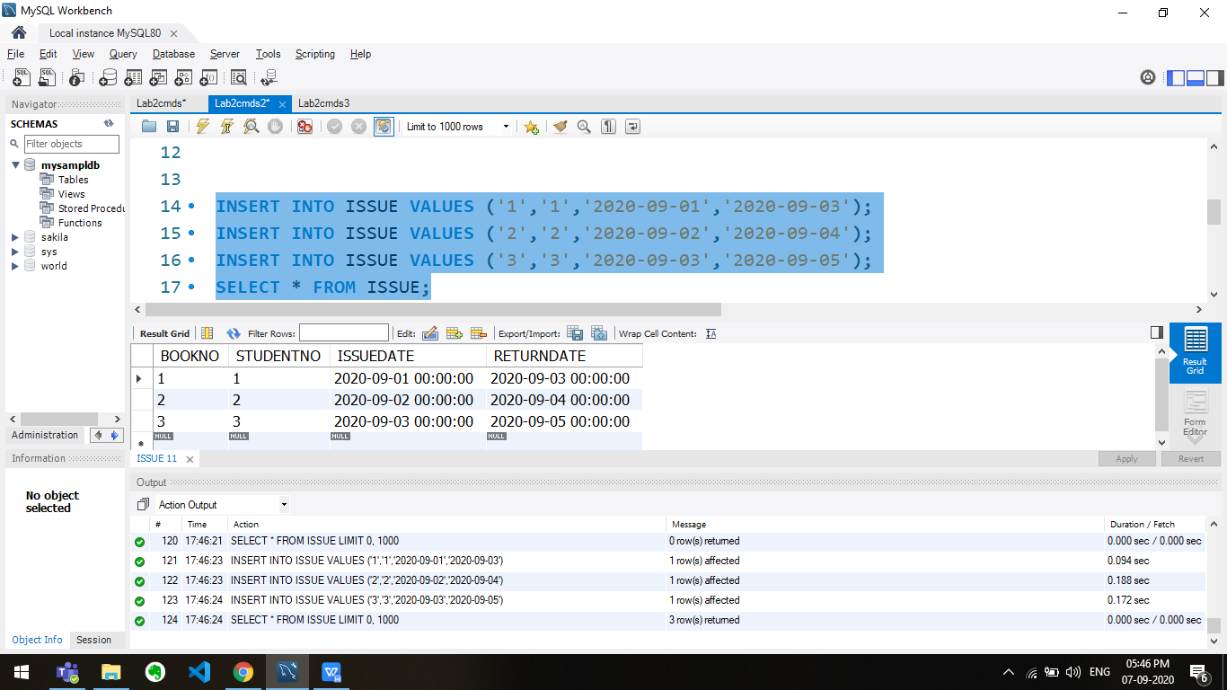

INSERT INTO ISSUE VALUES ('5','5',CURDATE(),CURDATE()+14);

SELECT * FROM ISSUE;

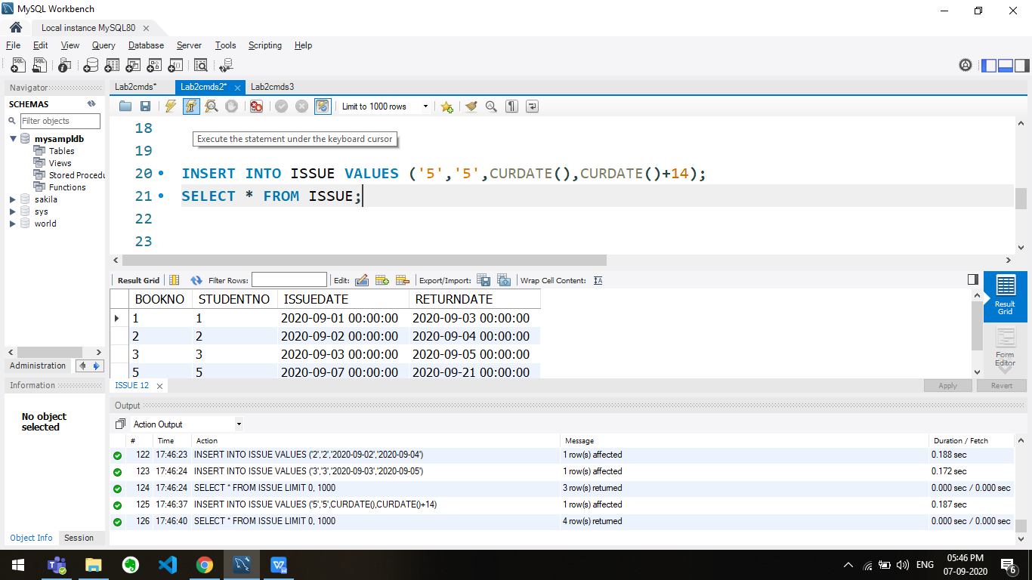

SELECT BOOKNO FROM ISSUE WHERE ISSUEDATE='2020-09-03';

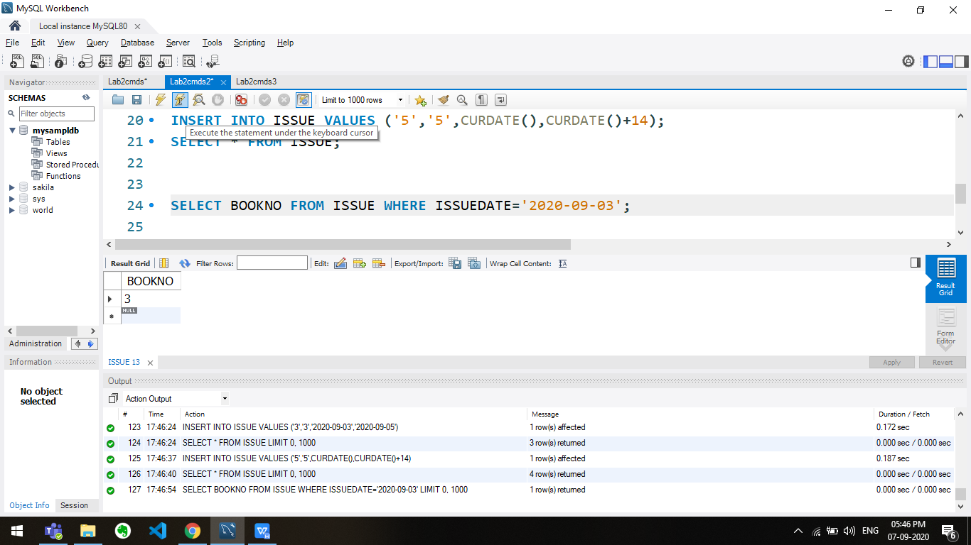

SELECT * FROM ISSUE WHERE RETURNDATE=CURDATE()+3;

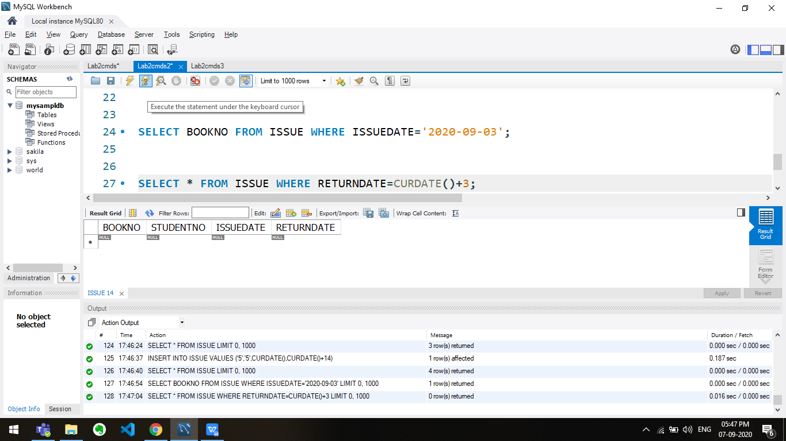

SELECT date_format(ISSUEDATE, '%M %e, %Y') FROM ISSUE;

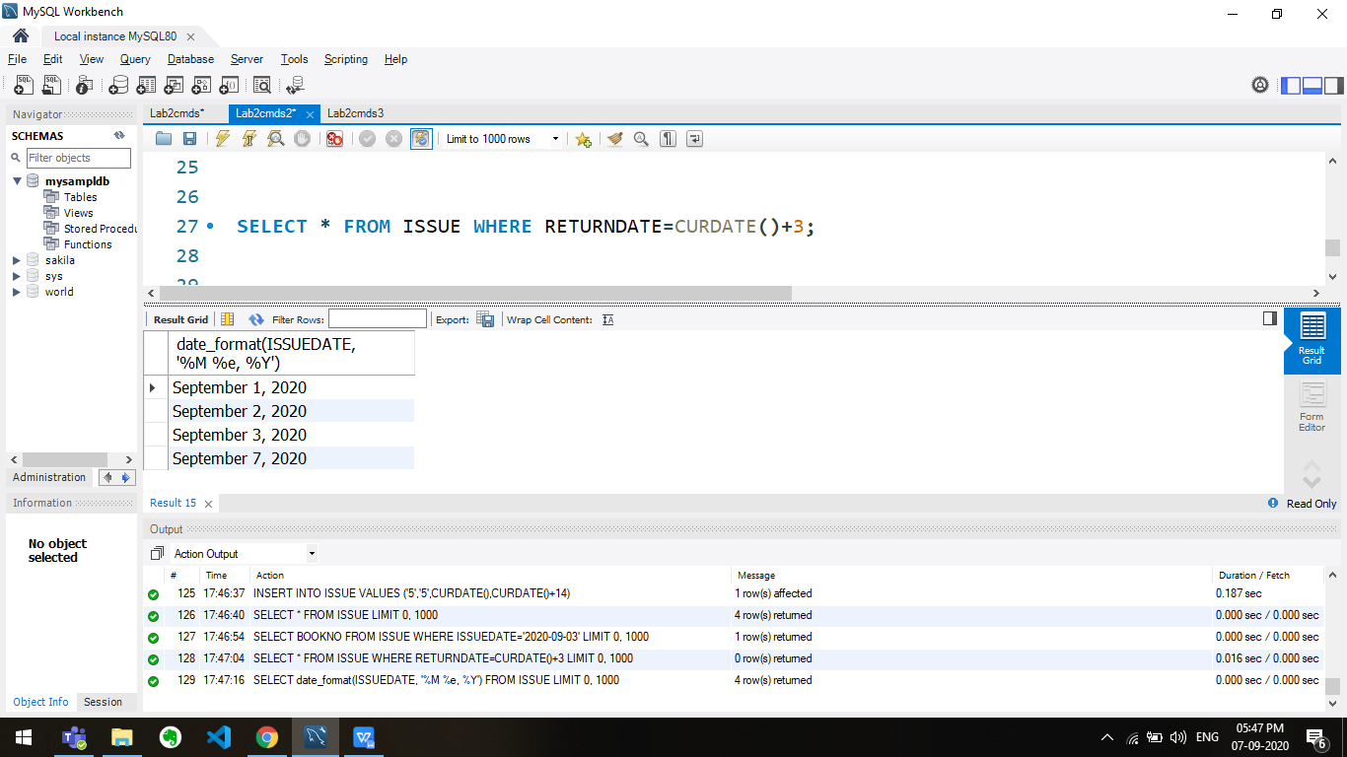

SELECT BOOKNO,EXTRACT(YEAR FROM ISSUEDATE) AS YEAR,EXTRACT(MONTH FROM ISSUEDATE) AS MONTH FROM ISSUE;

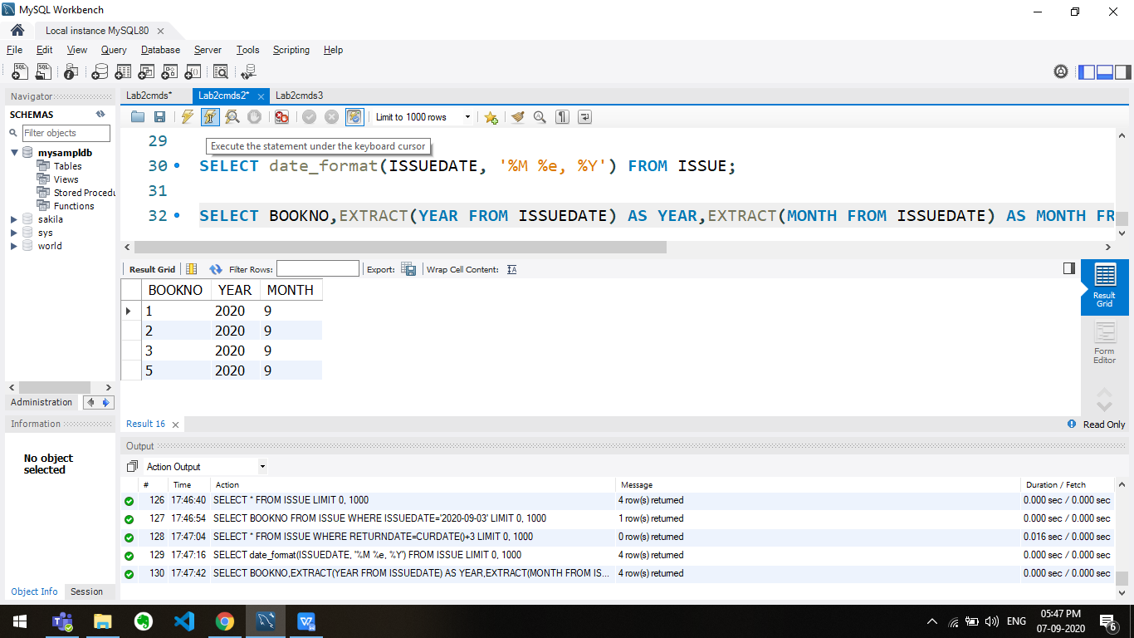

**Q3**

use mysampldb;

DROP TABLE EMP;

CREATE TABLE EMP(

EMPNO INT(6) NOT NULL,

ENAME VARCHAR(20) NOT NULL,

JOB VARCHAR(10) NOT NULL,

DEPT VARCHAR(10),

DEPTNO INT(3),

SAL DECIMAL(7,2),

PRIMARY KEY(EMPNO),

CHECK (SAL>0),

CHECK (DEPT IN ('CSE', 'IT', 'ECE', 'EEE', 'CIVIL'))

);

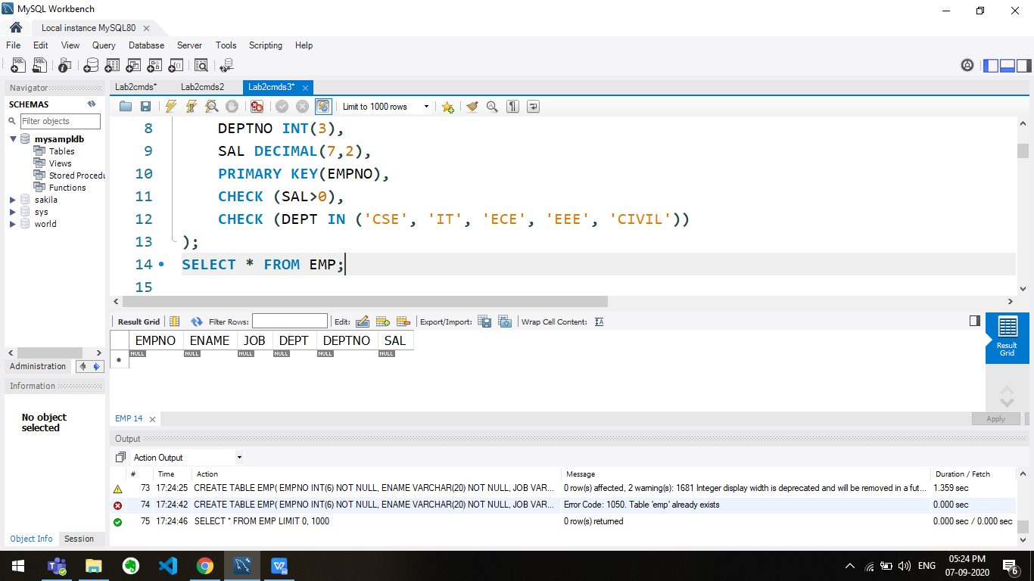

INSERT INTO EMP VALUES(1,'Arjun', 'Software', 'CSE', 106, 50000.00);

INSERT INTO EMP VALUES(2,'Arun', 'Construct', 'Civil', 104, 10000.00);

INSERT INTO EMP VALUES(3,'Bravo', 'AppDev', 'CSE', 106, 20000.00);

INSERT INTO EMP VALUES(4,'Duplesis', 'Hardware', 'ECE', 112, 30000.00);

INSERT INTO EMP VALUES(5,'Dhoni', 'Software', 'CSE', 106, 70000.00);

INSERT INTO EMP VALUES(6,'Raina', 'Wiring', 'EEE', 106, 15000.00);

INSERT INTO EMP VALUES(7,'Singh', 'WebDev', 'CSE', 106, 25000.00);

INSERT INTO EMP VALUES(8,'Solomon', 'Maintain', 'IT', 100, 20000.00);

INSERT INTO EMP VALUES(9,'Vijay', 'Maintain', 'IT', 100, 20000.00);

INSERT INTO EMP VALUES(10,'Watson', 'Comm.', 'ECE', 106, 25000.00);

SELECT * FROM EMP;

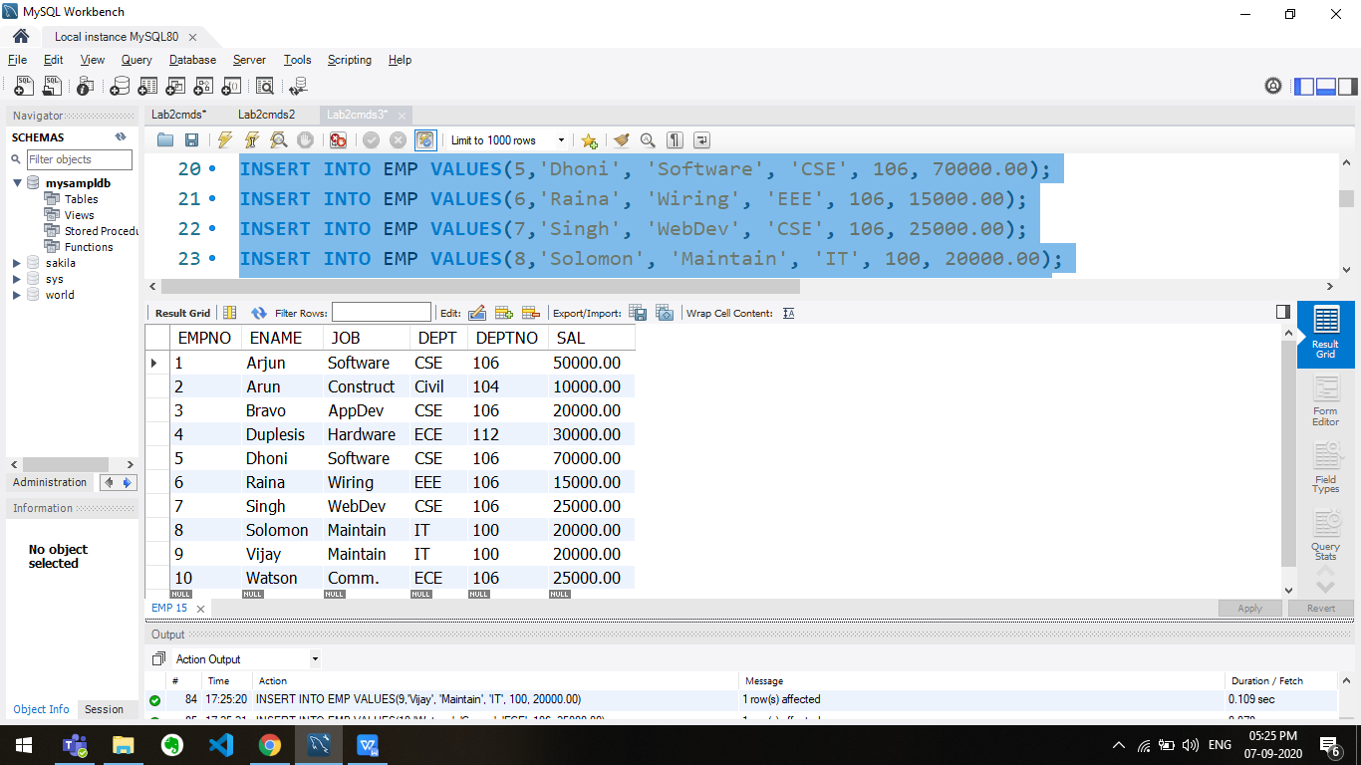

SELECT * FROM EMP WHERE ENAME LIKE 'A%';

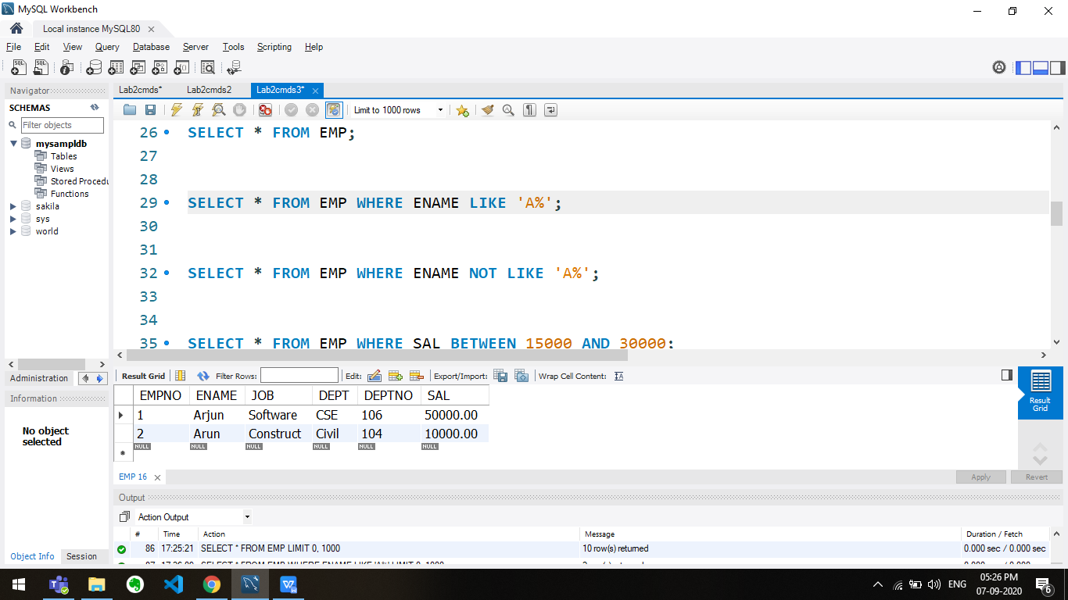

SELECT * FROM EMP WHERE ENAME NOT LIKE 'A%';

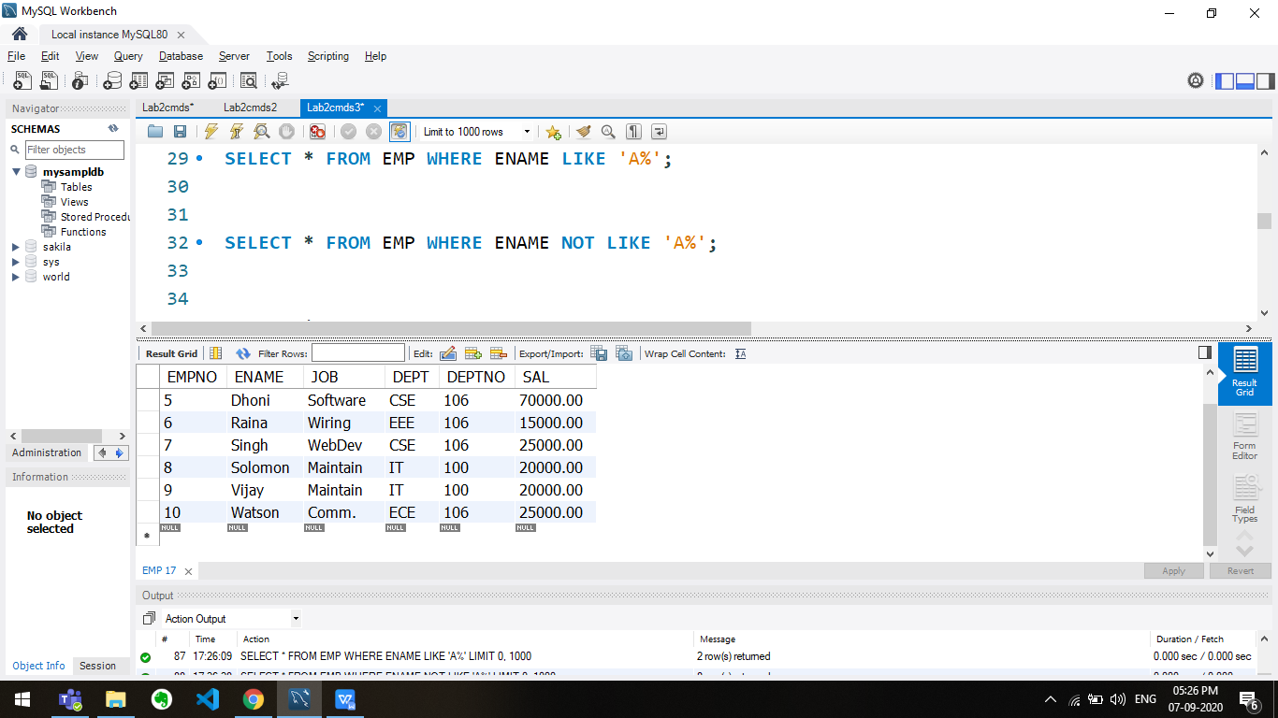

SELECT * FROM EMP WHERE SAL BETWEEN 15000 AND 30000;

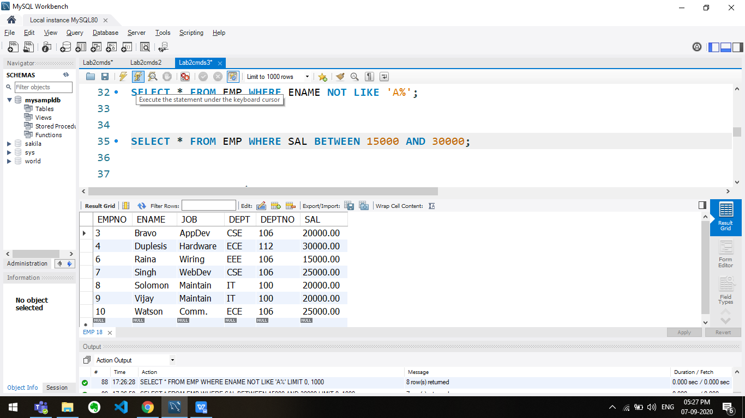

CREATE TABLE EMP1(

EMPNO INT(6) NOT NULL,

ENAME VARCHAR(20) NOT NULL,

JOB VARCHAR(10) NOT NULL,

DEPT VARCHAR(10),

DEPTNO INT(3),

SAL DECIMAL(7,2),

PRIMARY KEY(EMPNO),

CHECK (SAL>0),

CHECK (DEPT IN ('CSE', 'IT', 'ECE', 'EEE', 'CIVIL'))

);

SELECT * FROM EMP1;

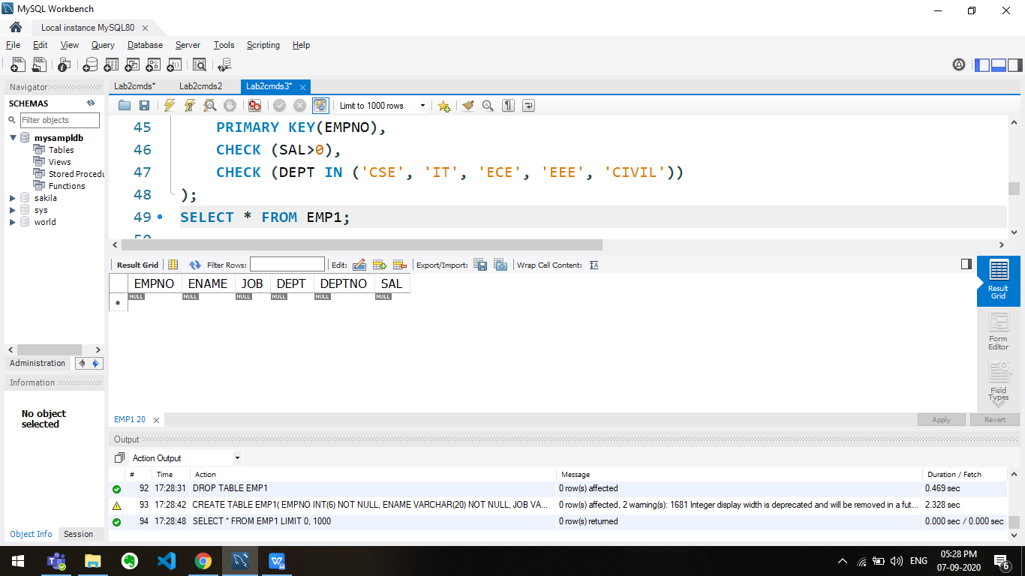

INSERT INTO EMP1 SELECT * FROM EMP WHERE DEPT='CSE';

SELECT * FROM EMP1;

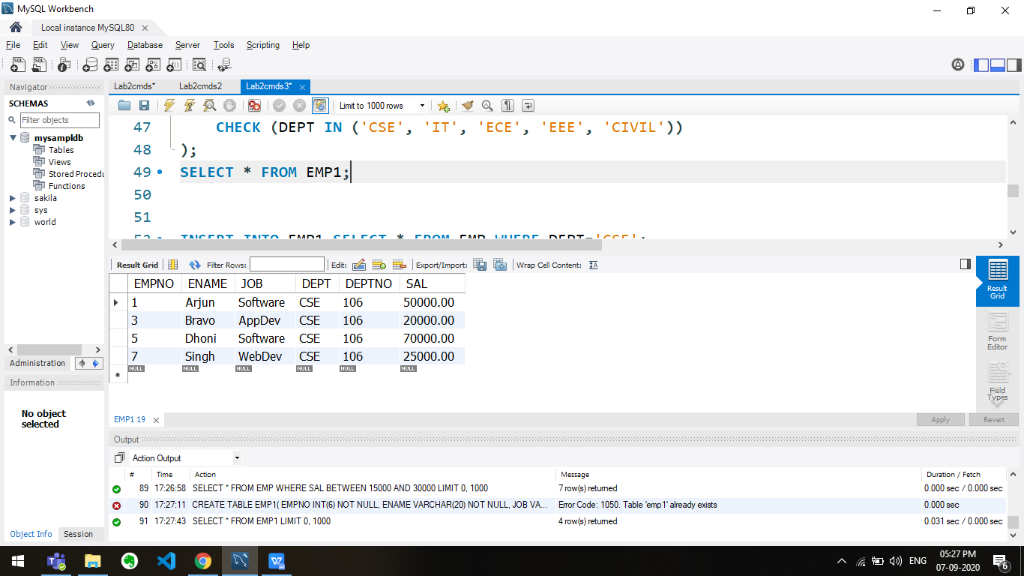

SELECT * FROM EMP ORDER BY DEPT;

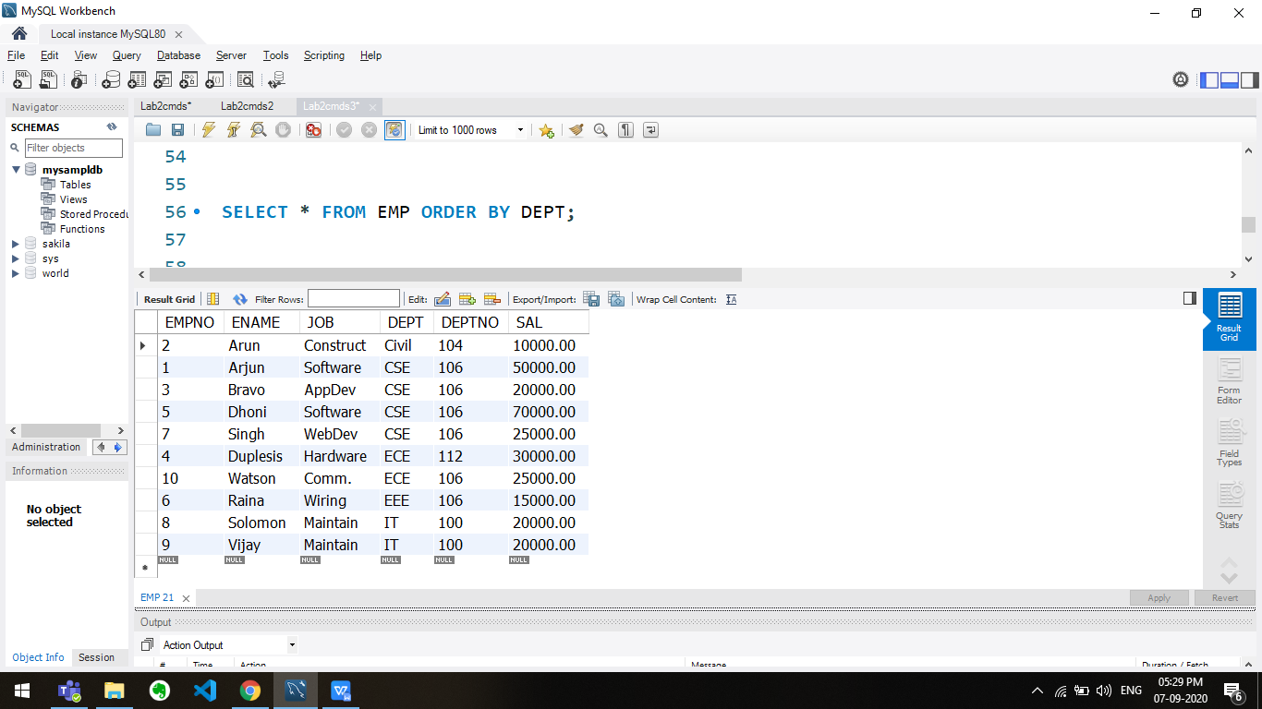

SELECT * FROM EMP ORDER BY JOB;

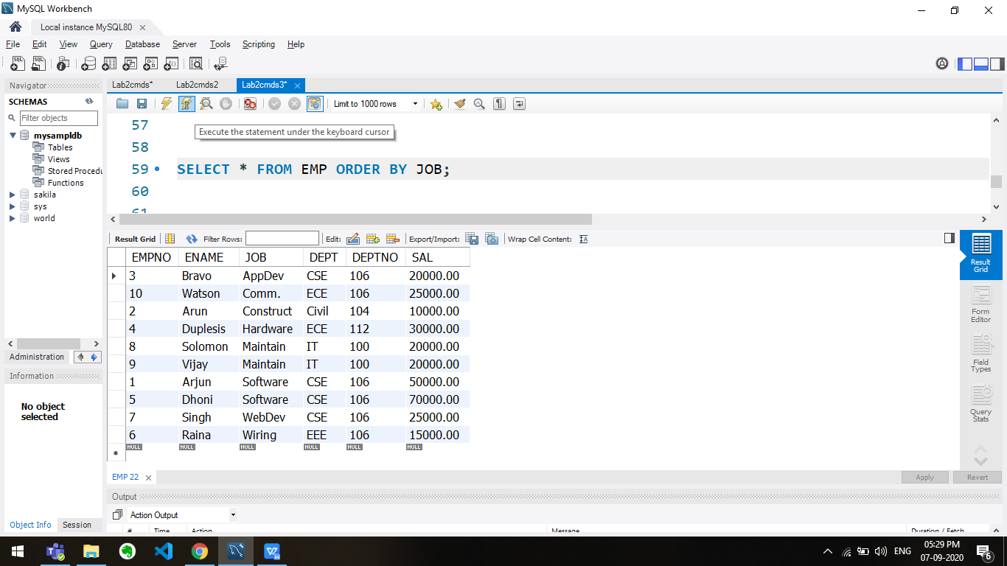

SELECT EMPNO, ENAME, SUBSTRING(DEPT,1,2) FROM EMP;

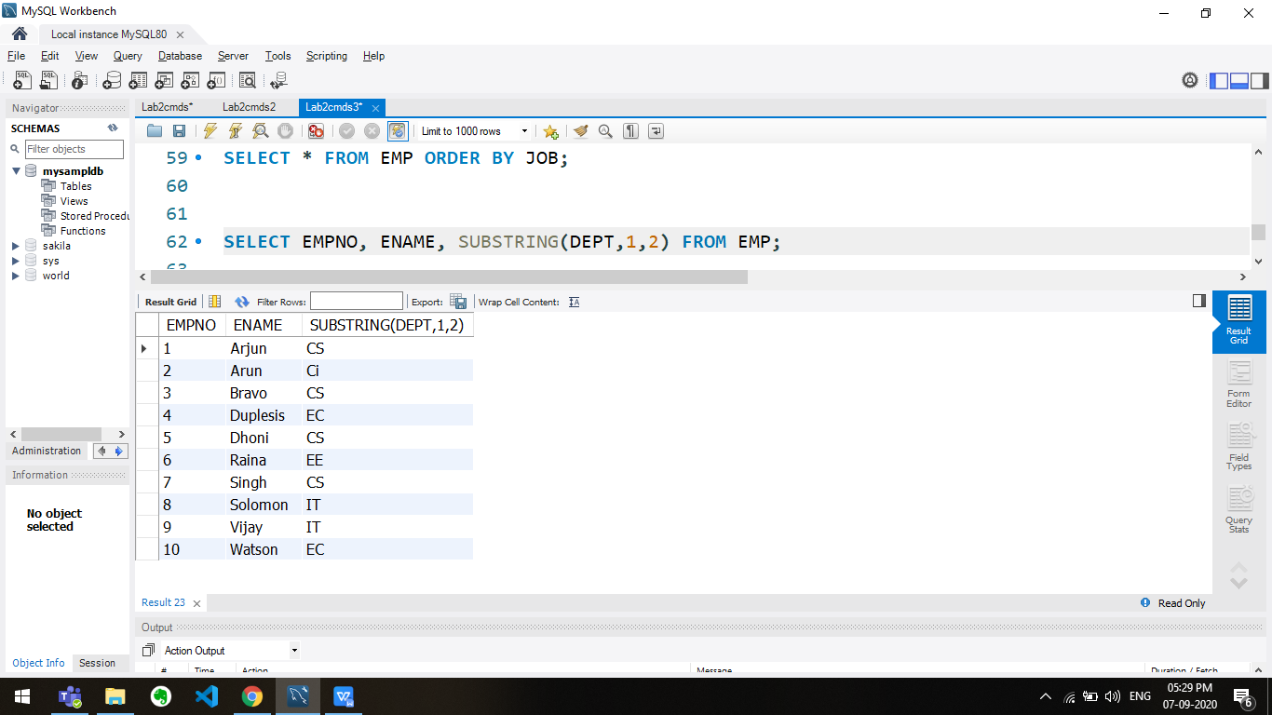

SELECT DISTINCT JOB FROM EMP;

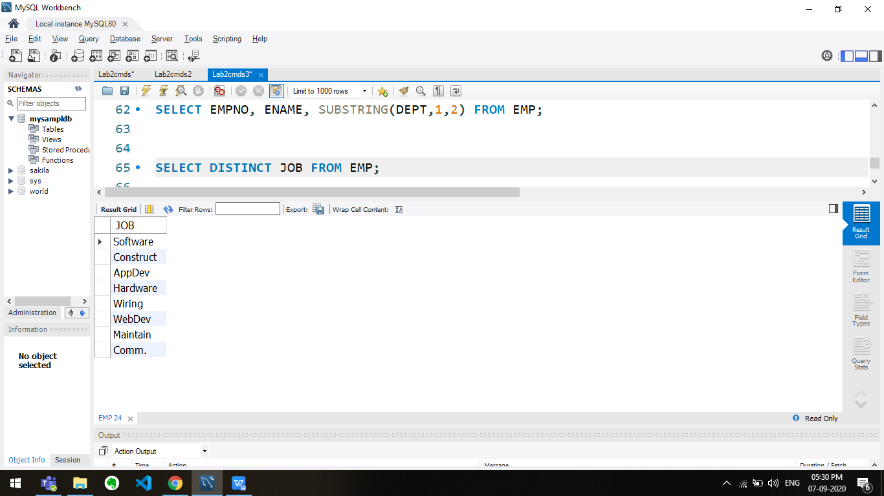

SELECT * FROM EMP WHERE ENAME IN ('Arjun','Arun', 'Solomon');

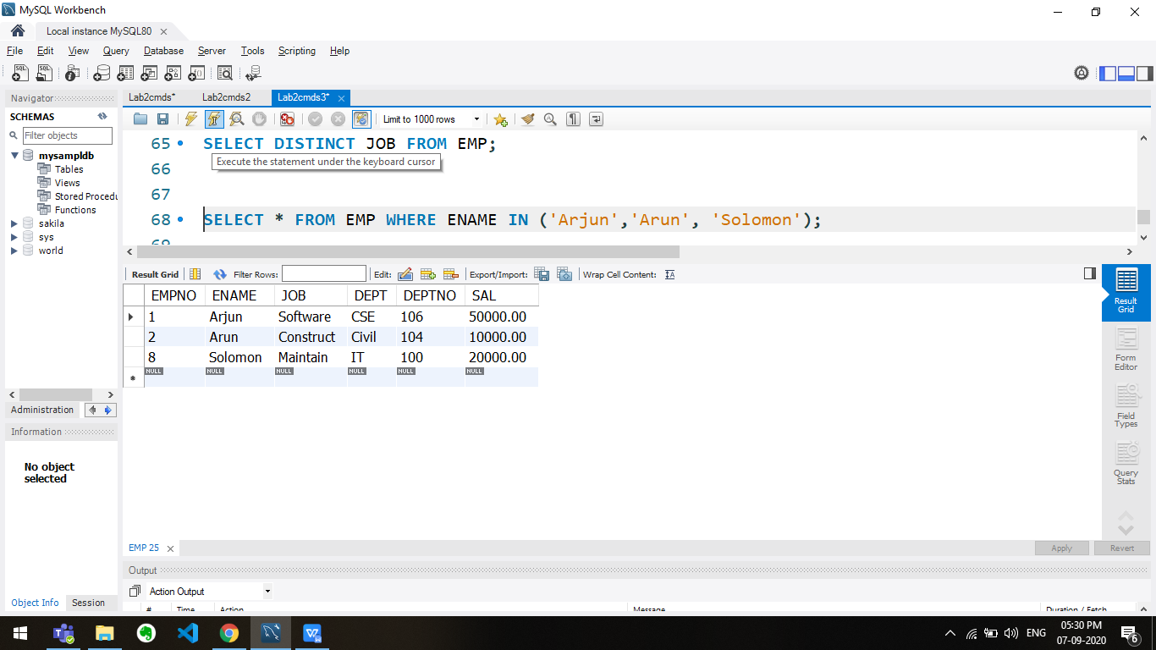

SELECT SUBSTRING(ENAME,2,3) FROM EMP;

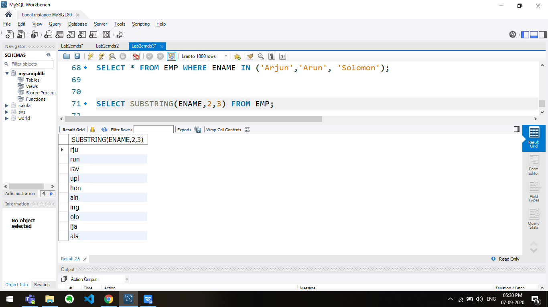

SELECT SUBSTRING(REVERSE(ENAME),5,3) FROM EMP;

